CSA CCM Compliance for Log360 Cloud
Strengthen cybersecurity and meet CSA CCM compliance with Log360.
Region: International | Type: Incident Management | Category: Compliance | Pricing: Free

Overview
The CSA CCM compliance extension in Log360 helps organizations meet the Cloud Security Alliance Cloud Controls Matrix (CSA CCM) v4, a cybersecurity controls framework with 197 controls across 17 domains for assessing and managing cloud security risk by providing centralized log management, real-time threat detection, and compliance-focused reporting. The platform supports CSA CCM requirements for identity and access management, security logging and monitoring, incident response, infrastructure security, encryption, data lifecycle protection, vulnerability management, endpoint security, and cloud forensics.
For Audit and Assurance Policy Compliance, Log360 provides comprehensive audit trail reports, automated compliance assessments, and centralized log management to support audit readiness and remediation tracking. To address Application and Interface Security Monitoring, the platform monitors application events, detects anomalous interface activity, and provides real-time alerting on application-layer threats including SQL injection and XSS. The extension also supports Business Continuity and Disaster Recovery Monitoring by providing capabilities that tracks backup and disaster recovery events, monitors infrastructure availability, and generates resilience reports for BCR compliance.

Key Features
- Change Control and Configuration Baseline Monitoring: Log360 monitors configuration changes across systems, alerts on unauthorized modifications, and provides change audit trails for compliance.
- Encryption and Key Management Audit Monitoring: Log360 monitors encryption-related events, tracks key management activities, and generates audit reports for encryption and key management compliance.
- Data Security and Privacy Lifecycle Protection: Log360 monitors data access patterns, detects unauthorized data transfers, and provides data protection audit reports for the data lifecycle.
- Governance Risk and Compliance Program Oversight: Log360 delivers centralized compliance dashboards, risk assessment reports, and regulatory mapping support to demonstrate GRC program effectiveness.
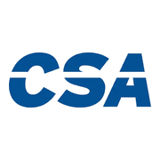
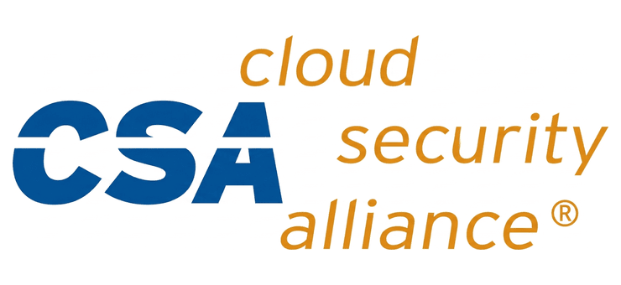

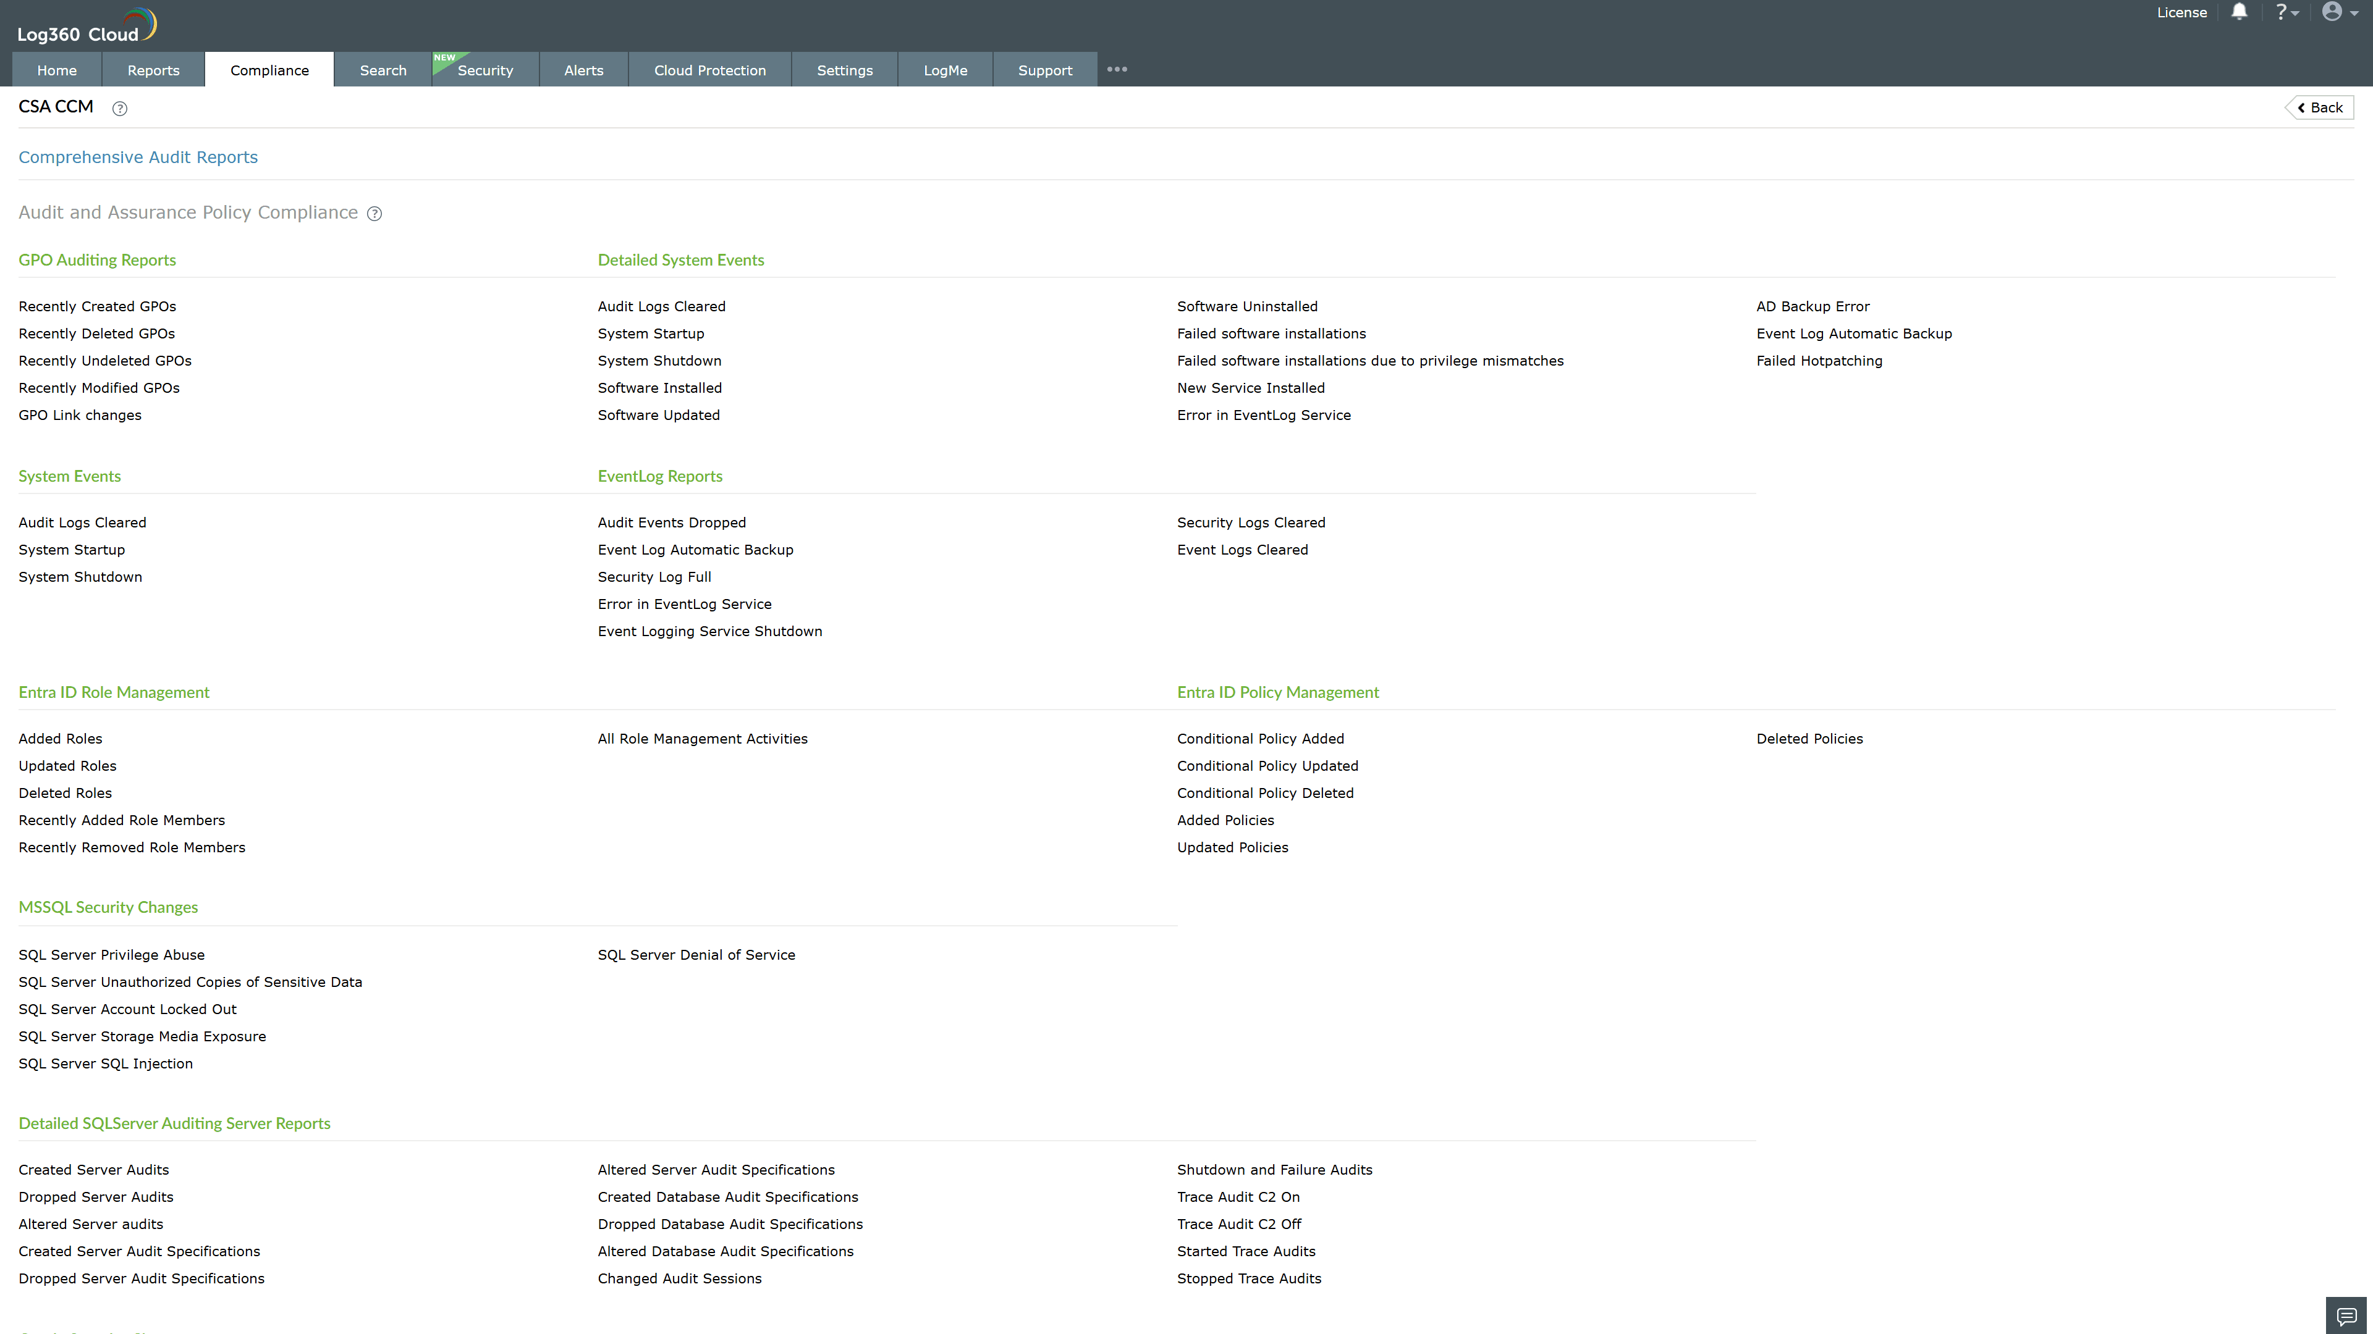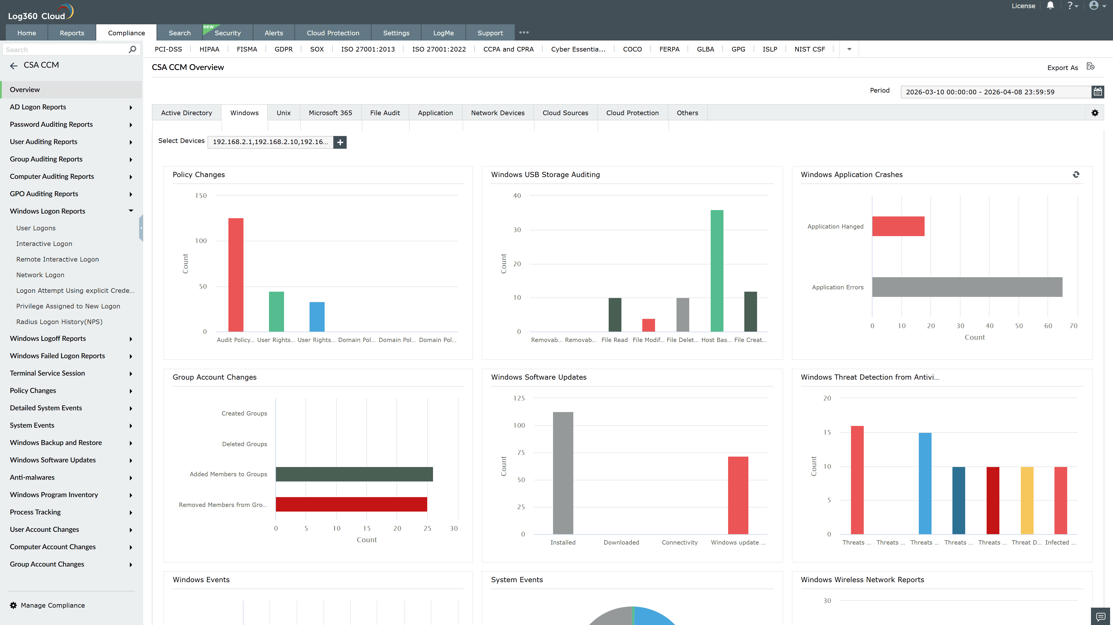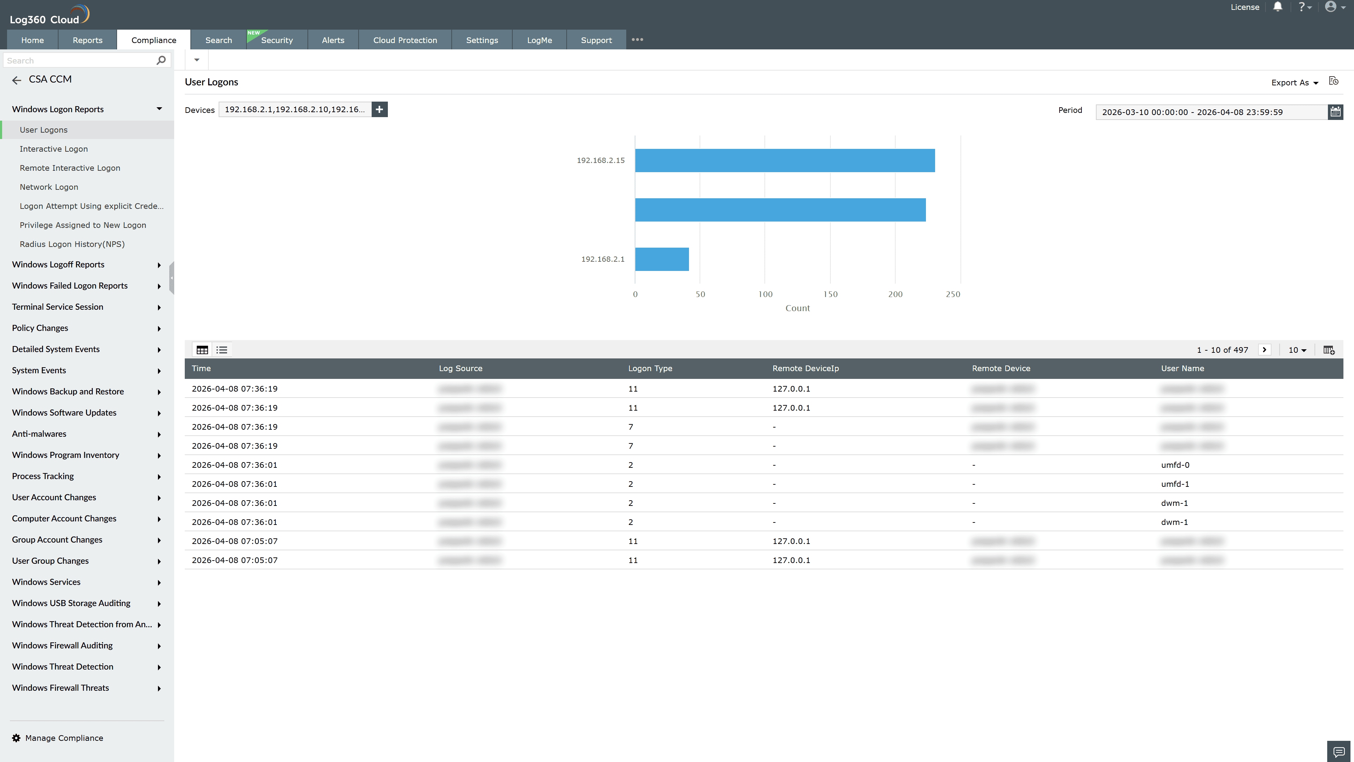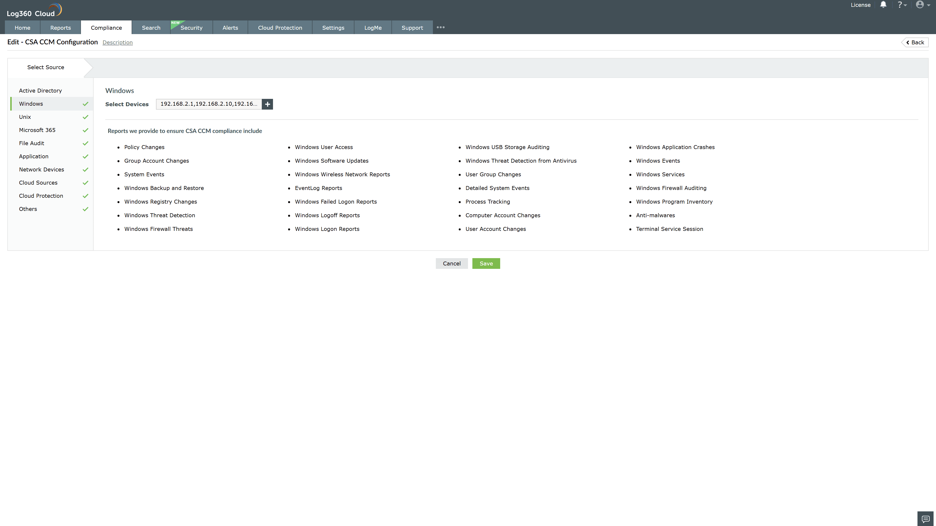
Valid Submission : Yes
Supported Editions : Free, Basic, Standard, Professional, MSSP
Help Document : https://www.manageengine.com/log-management/help/integrations/compliance-extensions.html
Help Video : Not provided
Tags : Log360, Compliance, Privacy monitoring, Data privacy, Regulatory compliance
Supported DCs : US, IN, JP, CA, AU, UK and EU
Privacy Policy:
Terms of Service:
Release Notes:
Predefined reports for the CSA CCM.

